**Why we need Data structures?**

Data structures are essential because they provide a way to organize and manage data efficiently, allowing for faster and more optimized operations. Here's an example to illustrate the need for data structures:

Consider a scenario where you need to store and process a large collection of student records. Each record contains information such as student ID, name, age, and grade. Without proper data structures, you would have to resort to using simple variables or arrays to store this data. However, this approach would have several limitations:

1. Inefficient Search: If you wanted to find a student record based on their ID or name, you would have to iterate through the entire collection, comparing each record until a match is found. This linear search would be time-consuming and inefficient, especially for large data sets.

2. Limited Sorting: Sorting the records based on a specific criterion, such as student ID or grade, would require implementing sorting algorithms from scratch. It would be challenging to maintain the order of records efficiently, especially if new records are added or existing ones are modified.

3. Insertion and Deletion Complexity: Adding or removing a student record would involve shifting the remaining records to accommodate the change. This process would be inefficient and time-consuming for large data sets, as it requires updating the entire collection.

By using appropriate data structures, such as an array, linked list, or hash table, you can overcome these limitations:

1. Efficient Search: With a data structure like a hash table or binary search tree, you can quickly locate a student record based on their ID or name. These data structures offer faster search algorithms that reduce search time significantly, even for large data sets.

2. Sorting Capability: Data structures like arrays or balanced binary search trees provide efficient sorting algorithms such as quicksort or merge sort, enabling you to sort the student records based on different criteria easily.

3. Faster Insertion and Deletion: Data structures like linked lists or dynamic arrays allow efficient insertion and deletion of student records. They avoid the need for shifting elements and provide constant-time insertion and deletion at the beginning or end of the collection.

Using appropriate data structures not only enhances the efficiency and performance of your code but also simplifies the implementation of operations like search, sort, insert, and delete. It enables you to handle large data sets more effectively and maintain data integrity and organization.

**Getters & Setters**

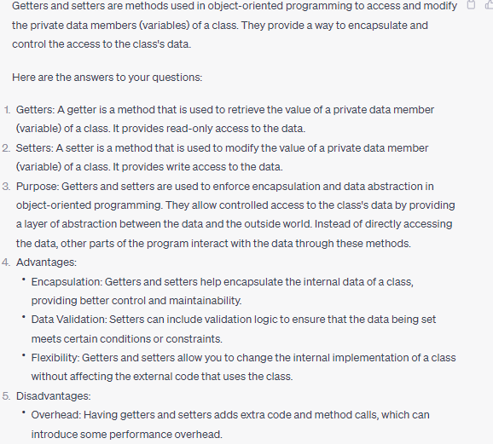

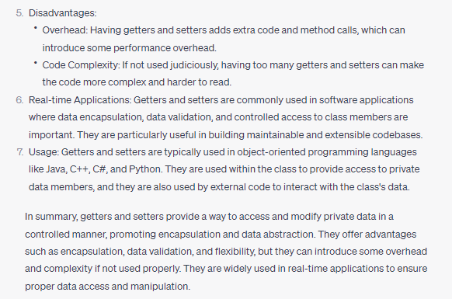

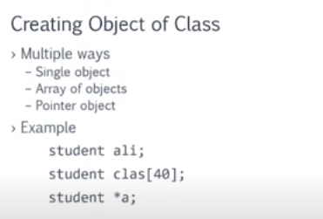

**Realtime examples of oop pillars**

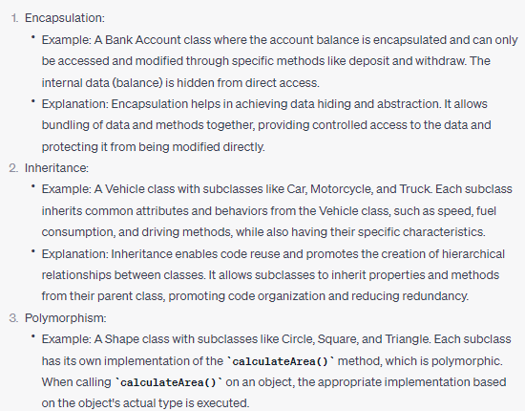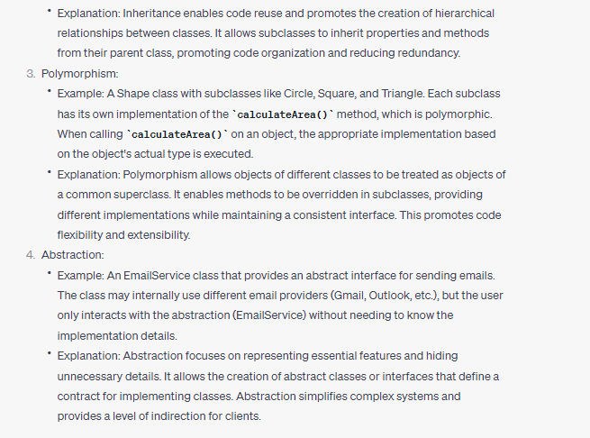

**Polymorphsm**

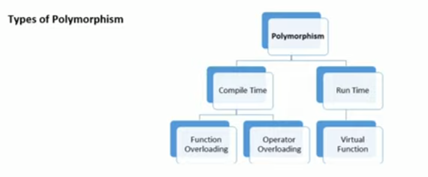

Polymorphism is a core concept in object-oriented programming (OOP) that allows objects of different classes to be treated as objects of a common base class. It enables flexibility, code reusability, and the ability to create code that is more abstract and extensible.

There are two types of polymorphism: static (compile-time) polymorphism and dynamic (runtime) polymorphism.

1. Static Polymorphism:

- Static polymorphism is achieved through method overloading and function templates.

- Method overloading allows multiple methods with the same name but different parameters in a class. The appropriate method is chosen at compile-time based on the arguments used during the function call.

- Function templates in C++ enable generic programming by defining a single function that can operate on different data types.

2. Dynamic Polymorphism:

- Dynamic polymorphism is achieved through method overriding and inheritance.

- Method overriding occurs when a derived class defines a method that is already present in its base class. The derived class provides its own implementation of the method, which is invoked at runtime based on the actual object type.

- Inheritance is a fundamental concept that enables dynamic polymorphism. It allows objects of a derived class to be treated as objects of their base class.

Polymorphism allows us to write code that can work with objects of different types, as long as they adhere to a common interface or inheritance hierarchy. This promotes code flexibility, extensibility, and modularity. It simplifies code maintenance, as changes made in one part of the codebase can propagate through the related classes.

Example:

```cpp

class Shape {

public:

virtual void draw() {

cout << "Drawing a shape." << endl;

}

};

class Circle : public Shape {

public:

void draw() override {

cout << "Drawing a circle." << endl;

}

};

class Square : public Shape {

public:

void draw() override {

cout << "Drawing a square." << endl;

}

};

int main() {

Shape* shape1 = new Circle();

Shape* shape2 = new Square();

shape1->draw(); // Output: "Drawing a circle."

shape2->draw(); // Output: "Drawing a square."

delete shape1;

delete shape2;

return 0;

}

```

In the above example, we have a base class `Shape` with a virtual `draw()` method. Two derived classes, `Circle` and `Square`, override the `draw()` method with their own implementations. By creating objects of these derived classes and assigning them to a base class pointer, we achieve dynamic polymorphism. The `draw()` method of each object is called based on the actual object type, allowing us to treat different shapes uniformly.

**Type casting**

Type casting refers to the conversion of one data type to another in a program. Typecasting can be done in two ways: automatically by the compiler and manually by the programmer or user. Type Casting is also known as Type Conversion.

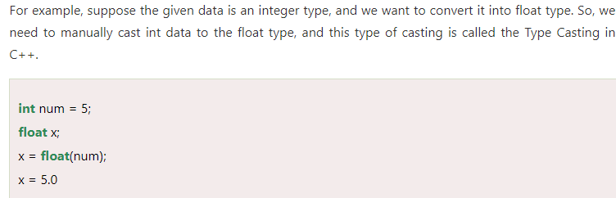

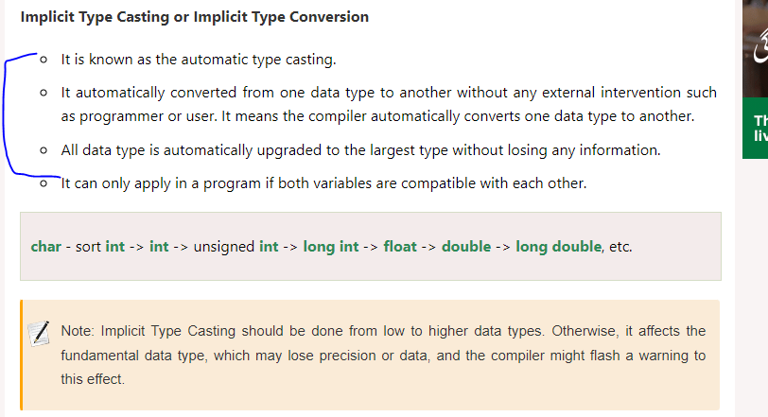

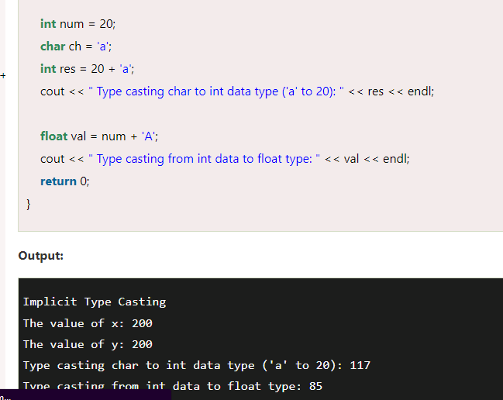

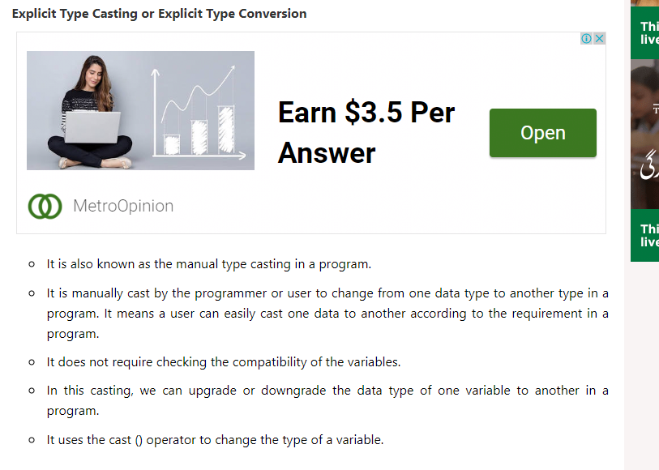 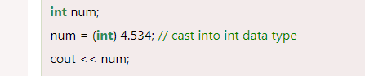 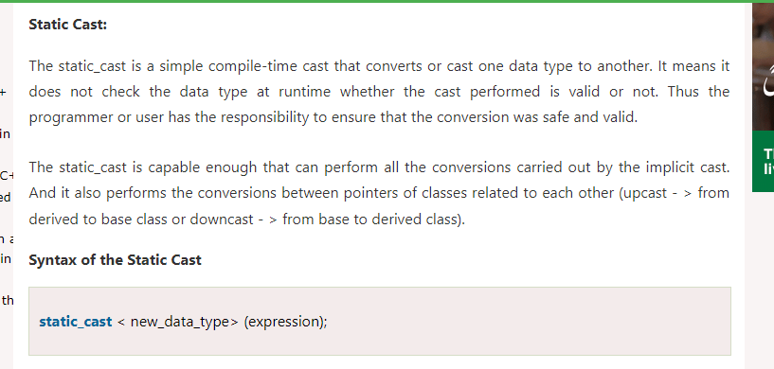 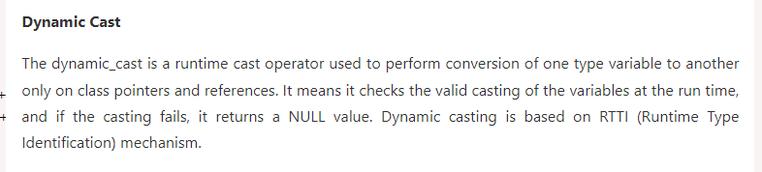

**Memory allocation for class members and functions when an object is made?**

**When we make an object of class then whats the memory allocation scene like is memory is allocated for datamembers and functions etc ? in c++**

Yes, when you create an object of a class in C++, memory is allocated for both the data members and member functions of the object. The amount of memory that is allocated depends on the size of the data members and the number of member functions in the class.

In general, the memory for the data members is allocated on the stack or the heap, depending on how the object is created. If the object is created as a local variable, then the memory for its data members is allocated on the stack. On the other hand, if the object is created using the "new" keyword, then the memory for its data members is allocated on the heap.

The member functions of a class, on the other hand, are typically not allocated memory for each object. Instead, they are stored in a single location in memory and are shared by all objects of the class. This is because member functions are usually the same for all objects of a class, and allocating memory for each one would be inefficient.

It's worth noting that there are some exceptions to this rule, particularly when it comes to virtual functions and classes with virtual inheritance. In these cases, additional memory may be allocated to store information about the class hierarchy and the virtual function table.

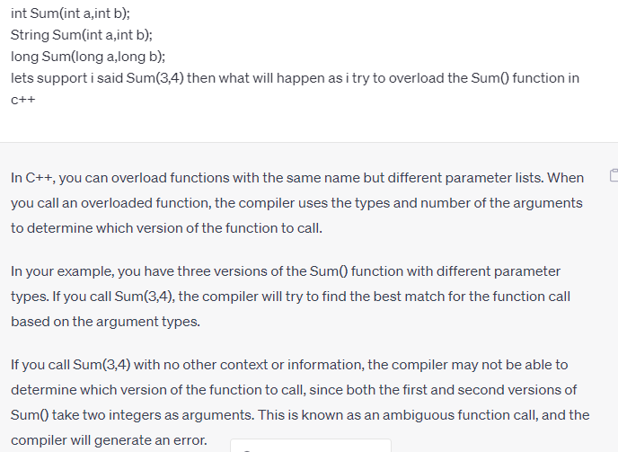

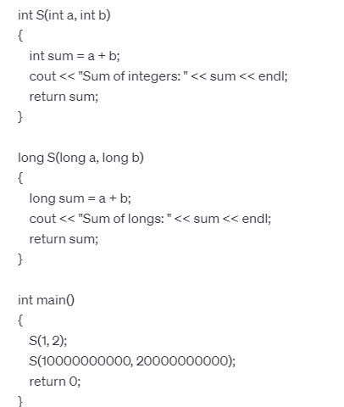



The function with the type "long" is called for **S(10000000000, 20000000000)** because the arguments passed to this function call are both very large numbers, which are too big to fit in the range of an **int** data type.

In C++, the range of **int** data type is typically from -2147483648 to 2147483647, depending on the implementation. When you pass the values **10000000000** and **20000000000** to the function call, they exceed this range, so they are automatically promoted to the **long** data type.

Since the second overloaded function **S(long a, long b)** has a **long** data type for its parameters, it is a better match for the passed arguments than the **S(int a, int b)** function, which has an **int** data type for its parameters. Therefore, the **S(long a, long b)** function is called and produces the correct result.

What are abstract classes?

* Abstract classes are classes that cannot be instantiated on their own but serve as a base for other classes to be derived from. They are used to define a common interface for the derived classes.

Why do we need abstract classes?

* We need abstract classes to provide a common base for related classes. They also allow for the definition of abstract methods, which are required to be implemented by the derived classes, ensuring that they all have a consistent interface. Sometimes implementation of all function cannot be provided in a base class because we don’t know the implementation. Such a class is called abstract class. For example, let Shape be a base class. We cannot provide implementation of function draw() in Shape, but we know every derived class must have implementation of draw(). Similarly an Animal class doesn’t have implementation of move() (assuming that all animals move), but all animals must know how to move. We cannot create objects of abstract classes.

What are the advantages of abstract classes?

* Abstract classes provide a level of abstraction, allowing for a clear separation of concerns between the base class and the derived classes. They also promote code reusability and maintainability by defining a consistent interface for the derived classes.

What are the disadvantages of abstract classes?

* One potential disadvantage of abstract classes is that they can lead to a more complex design, especially if there are multiple levels of inheritance. Additionally, using abstract classes may require more code to be written than using interfaces.

Why do we use abstract classes?

* We use abstract classes to provide a common base for related classes and to ensure that they all have a consistent interface. They also promote code reusability and maintainability.

How do we implement abstract classes?

* To implement an abstract class in Java, we define it using the abstract keyword before the class declaration. We can also define abstract methods within the class using the abstract keyword before the method declaration.

What are the real-time applications of abstract classes?

* Abstract classes are commonly used in object-oriented programming to define a common base for related classes. They are used in frameworks and libraries to provide a consistent interface for the derived classes to implement.

What are some examples of abstract classes?

* Some examples of abstract classes in Java include the InputStream and OutputStream classes in the java.io package, which define a common interface for input and output streams. Another example is the Shape class in the java.awt package, which serves as a base class for 2D shapes such as rectangles and circles. 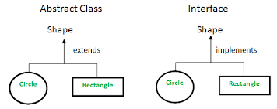

**Important Points**

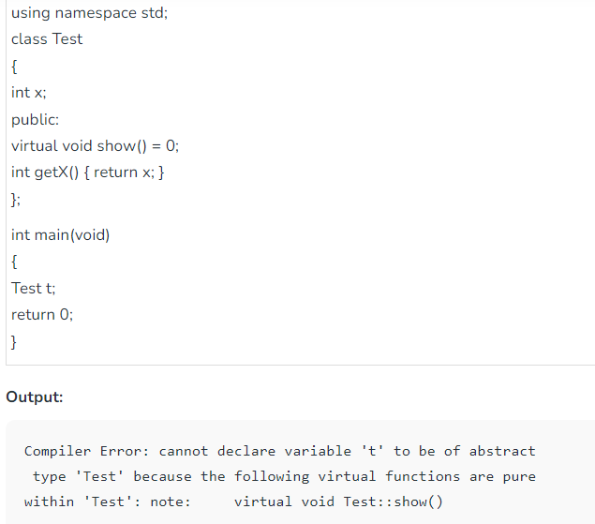

Figure We cannot make objects of abstract class.

**Important Thing**

*We can have pointers and references of abstract class type.*   
For example the following program works fine.

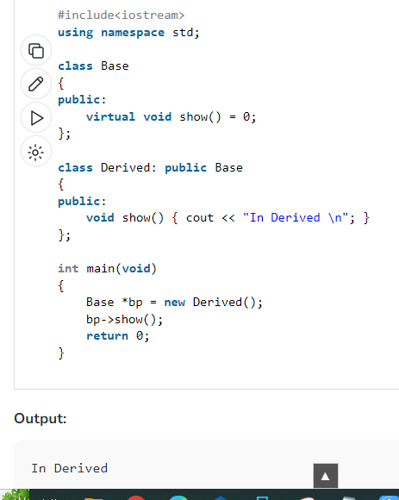

***Important Point***

*If we do not override the pure virtual function in derived class, then derived class also becomes abstract class.*   
The following example demonstrates the same.

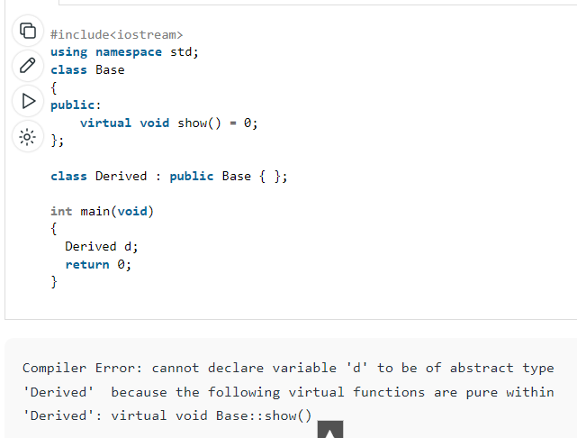

*An abstract class can have constructors.*

[**https://www.geeksforgeeks.org/pure-virtual-functions-and-abstract-classes/**](https://www.geeksforgeeks.org/pure-virtual-functions-and-abstract-classes/)

[**https://www.geeksforgeeks.org/c-interview-questions-on-virtual-function-and-abstract-class/?ref=rp**](https://www.geeksforgeeks.org/c-interview-questions-on-virtual-function-and-abstract-class/?ref=rp)

**Can we extend Abstract Classes?**

Yes, we can extend abstract classes in C++. When we extend an abstract class, we are creating a concrete class that inherits all the properties and methods of the abstract class, and is required to implement all the pure virtual functions of the abstract class. 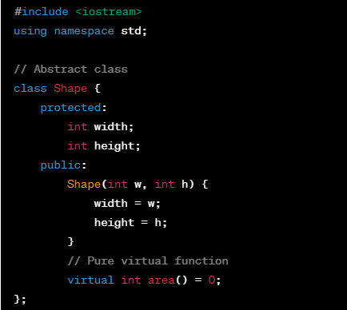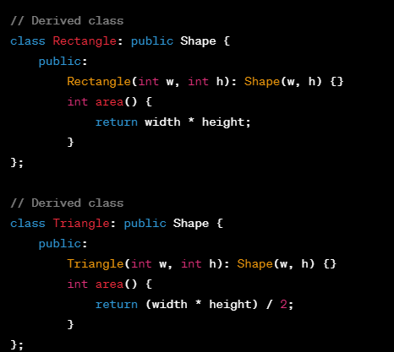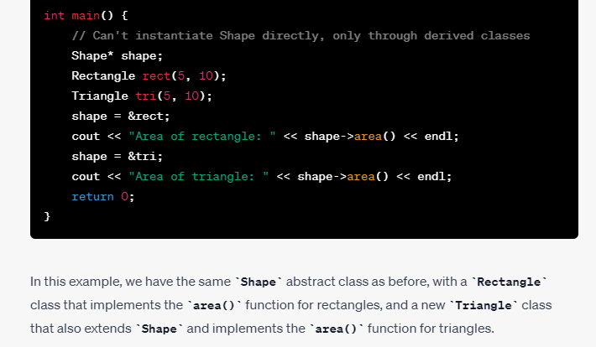

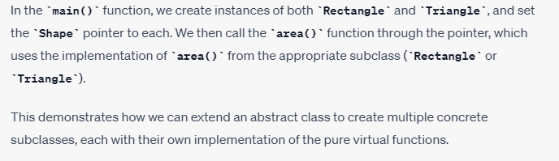

**Interfaces**

1. What are interfaces?

* An interface is a blueprint of a class that defines a set of methods without implementation. It specifies the behavior of the class but does not provide the implementation details of the methods.

1. Why do we need interfaces?

* Interfaces provide a way to achieve abstraction in object-oriented programming.
* They allow classes to interact with each other without knowing the implementation details of each other.
* Interfaces promote code reusability and flexibility in code design.

1. What are the advantages of interfaces?

* Interfaces allow classes to be more modular and loosely coupled.
* They help to enforce a common behavior across multiple classes.
* Interfaces allow for better code organization and management.

1. What are the disadvantages of interfaces?

* Interfaces can sometimes lead to code duplication if they are not designed properly.
* Implementing too many interfaces can make code more complex and harder to understand.
* Interfaces can sometimes be misused, leading to unnecessary complexity in code.

1. Why do we use interfaces?

* Interfaces are used to define a common behavior that can be shared across multiple classes.
* They are used to enforce a contract between classes that implement the interface.
* Interfaces are used to achieve abstraction and make code more modular and flexible.

1. How do we implement an interface?

* To implement an interface, a class must use the "implements" keyword followed by the name of the interface.
* The class must provide implementation for all the methods declared in the interface.

1. What are the real-time applications of interfaces?

* Interfaces are commonly used in software design patterns such as the Factory Method pattern and the Strategy pattern.
* They are used in many Java frameworks such as Spring and Hibernate.
* Interfaces are used to define APIs in libraries and SDKs.

1. What are some examples of interfaces?

* Java provides many examples of interfaces such as the Comparable interface and the Serializable interface.
* C# has interfaces such as the IDisposable interface and the IEnumerable interface.
* Python has interfaces such as the Abstract Base Classes (ABCs) in the collections module.

1. Can we extend an interface? If yes, what does it mean? Explain with an example in C++.

* Yes, we can extend an interface in some programming languages such as Java and C#.
* Extending an interface means creating a new interface that inherits the methods and properties of the base interface and adding new methods and properties to it.
* In C++, there are no interfaces, but we can achieve similar functionality using abstract classes. We can create a base abstract class and then create derived classes that implement the abstract methods of the base class. We can then use these derived classes polymorphically to achieve abstraction. Here is an example:

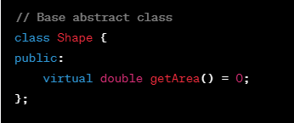

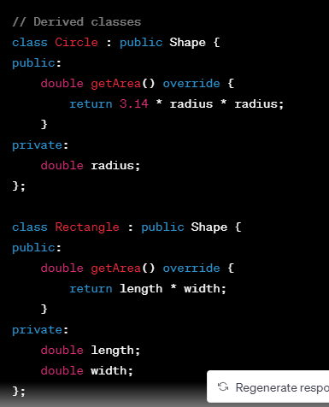

In this example, we have created an abstract class **Shape** with a pure virtual function **getArea()**. We have then created two derived classes **Circle** and **Rectangle** that implement the **getArea()** method. We can use these classes polymorphically to calculate the areas of circles and rectangles without knowing their implementation details.

**What happen if i make a interface in c++ and does not provide implemetation of pure virtual functions in derived classes?**

If a class inherits from an interface (pure virtual class) in C++ and does not provide implementation of all the pure virtual functions in the derived class, then the derived class will also become an abstract class. This means that the derived class cannot be instantiated on its own and can only be used through pointers or references of the base interface class.

When an attempt is made to create an object of such a derived class, a compiler error will occur since the derived class is incomplete due to unimplemented pure virtual functions. The error message will typically indicate that the class is abstract and cannot be instantiated.

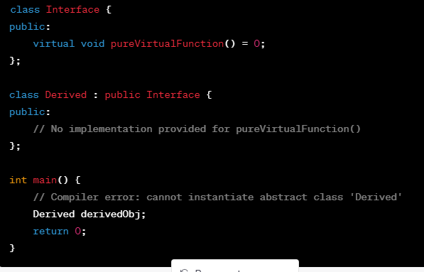

In the above example, since **Derived** does not provide an implementation for **pureVirtualFunction()** inherited from the **Interface**, it becomes an abstract class. Attempting to instantiate an object of **Derived** will result in a compiler error since it is incomplete due to the unimplemented pure virtual function.

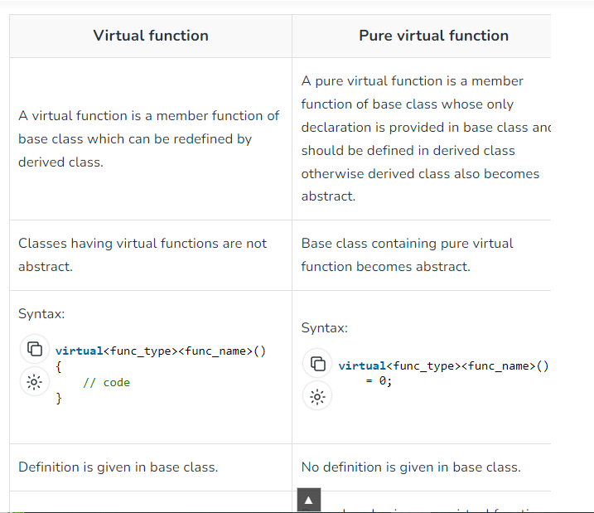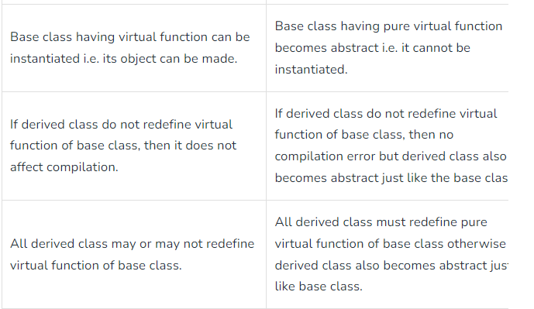

**Copy Constructors**

A copy constructor is a special constructor in C++ that creates an object by initializing it with an existing object of the same class.

Why we need a copy constructor? In C++, a copy constructor is used to create a new object as a copy of an existing object. This can be useful in a number of situations, such as when passing an object as a function argument or when returning an object from a function. It allows for the creation of a new object with the same state as an existing object, without modifying the existing object.

Advantages of Copy Constructor:

1. Allows creation of new objects based on existing objects with the same state.
2. Can simplify the code by making it easier to copy objects.
3. Can be useful in passing objects as function arguments or returning objects from functions.

Disadvantages of Copy Constructor:

1. Can result in performance issues if not used correctly.
2. Can be confusing to understand and use.

Why we use a copy constructor? We use a copy constructor to create a new object as a copy of an existing object, without modifying the existing object.

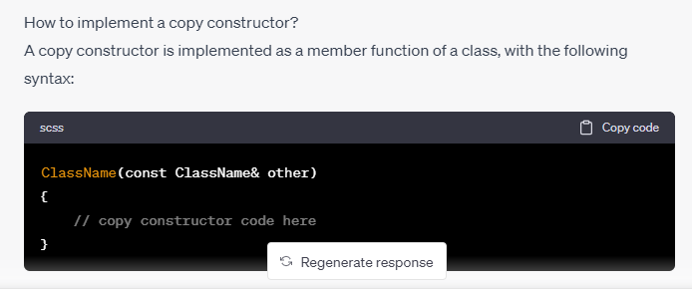

Real-time applications of Copy Constructor:

1. Creating copies of objects for use in different parts of a program.
2. Creating backups of objects for use in case of data loss or corruption.
3. Creating objects with the same state as existing objects for use in different parts of a program.

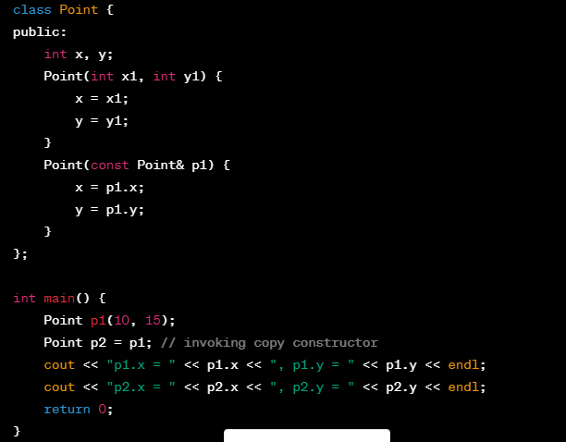

In the above example, the **Point** class has a copy constructor that creates a new object by copying the state of an existing object. The main function creates two **Point** objects, **p1** and **p2**, with **p2** being created using the copy constructor. The output shows that **p1** and **p2** have the same state.

In the above code example, a shallow copy is being used in the copy constructor of the **Point** class. A shallow copy creates a new object with a copy of the original object's pointer values, but does not create new copies of the data pointed to by the original object's pointers. In this case, since the **Point** class only contains integer values, a shallow copy is sufficient. However, if the class contained pointers to dynamically allocated memory or other complex data types, a deep copy would be necessary to ensure that the new object has its own copy of all the data.

**Shallow Copy vs Deep Copy**

In C++, shallow copy and deep copy are two ways of copying objects.

A shallow copy creates a new object with a copy of the original object's pointer values, but does not create new copies of the data pointed to by the original object's pointers. In other words, the copied object and the original object share the same memory addresses for the data pointed to by the pointers. If the original object is deleted or its data is modified, the copied object will be affected as well.

A deep copy, on the other hand, creates a new object and creates new copies of all the data pointed to by the original object's pointers. In this way, the copied object has its own separate memory for all of its data, and changes made to the original object will not affect the copied object.

In summary, the main difference between a shallow copy and a deep copy is that a shallow copy creates a new object that shares the same data as the original object, while a deep copy creates a new object with its own separate copy of all the data.

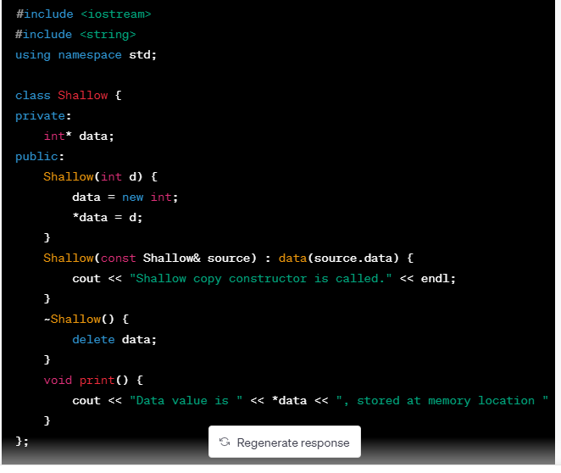

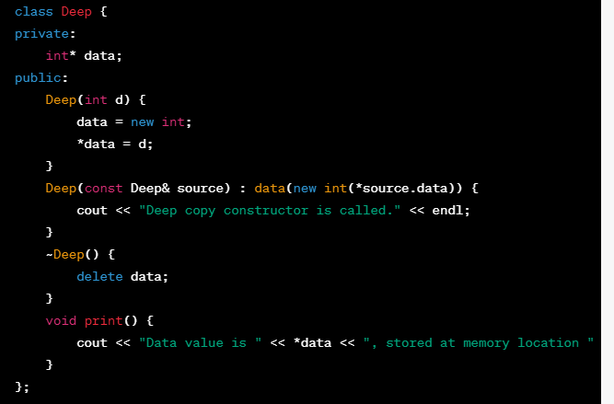

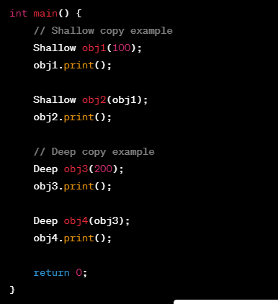

In this example, we have two classes: **Shallow** and **Deep**. The **Shallow** class uses a shallow copy in its copy constructor, while the **Deep** class uses a deep copy.

In the **main** function, we create an object **obj1** of the **Shallow** class and an object **obj3** of the **Deep** class. Both objects are initialized with a value of 100 and 200 respectively, and their data values are printed using the **print** method.

Next, we create a new object **obj2** of the **Shallow** class and pass **obj1** as an argument. This calls the copy constructor of **Shallow**, which performs a shallow copy of the data pointer. We then print the data values of both objects using the **print** method, and we can see that they share the same memory location for the data value.

Finally, we create a new object **obj4** of the **Deep** class and pass **obj3** as an argument. This calls the copy constructor of **Deep**, which performs a deep copy of the data pointer. We then print the data values of both objects using the **print** method, and we can see that they have separate memory locations for the data value.

The difference between using the copy constructor, assignment operator, and constructor syntax in terms of shallow and deep copy is as follows:

1. Copy Constructor: The copy constructor creates a new object as a copy of an existing object. It initializes the new object with the data of the existing object. A copy constructor can be used to create a deep copy or a shallow copy of an object, depending on how it is implemented.
2. Assignment Operator (=): The assignment operator is used to copy the values of one object to another object. When an object is assigned to another object using the assignment operator, the data of the original object is copied to the new object. Like the copy constructor, the assignment operator can be used to create a deep copy or a shallow copy of an object.
3. Constructor Syntax: Constructor syntax is used to create a new object and initialize its data members. When an object is created using constructor syntax, the data members of the object are initialized to the specified values. Constructor syntax is always used to create a deep copy of an object, as it creates a new object with its own memory.

To determine whether a copy constructor, assignment operator, or constructor syntax creates a shallow copy or a deep copy, you need to look at how the copy is implemented. A shallow copy copies only the pointers to the data members, while a deep copy creates new memory and copies the data to the new memory.

Here's an example that demonstrates the difference between shallow copy and deep copy using the copy constructor and assignment operator in C++:

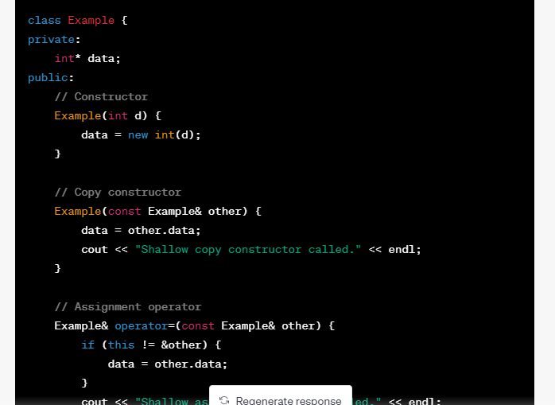

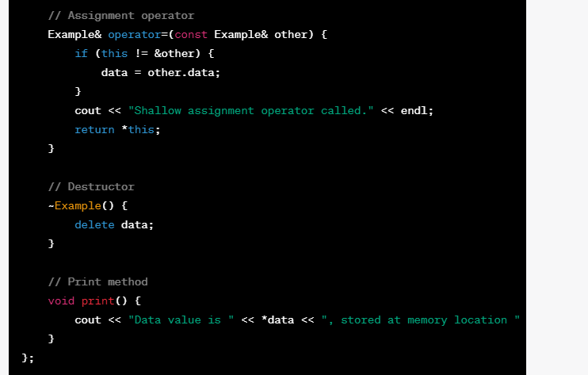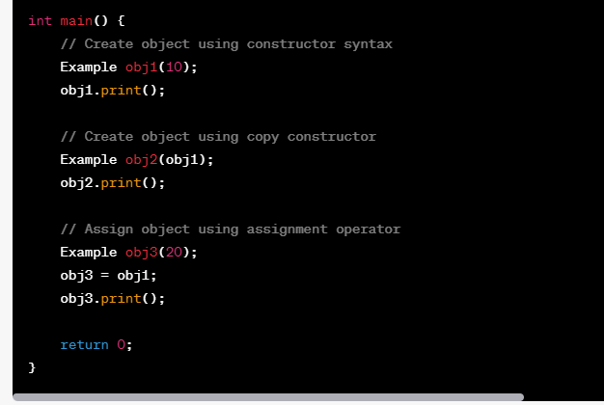

In this example, we have a class **Example** with a single integer data member **data**. The class has a constructor, copy constructor, assignment operator, and destructor.

We create three objects of the **Example** class: **obj1**, **obj2**, and **obj3**. **obj1** is created using constructor syntax and is initialized with a value of 10. **obj2** is created using the copy constructor and is a copy of **obj1**. **obj3** is created using constructor syntax and is initialized with a value of 20. We then assign **obj1** to **obj3** using the assignment operator.

In this example, the copy constructor and assignment operator perform a shallow copy, because they simply copy the pointer to the data member. Therefore, when we modify the data value of one object, the data value of the other objects is also modified. This is evident in the output of the program, where we see that the shallow copy

**Function overriding vs Polymorphism**

Polymorphism is a fundamental concept of object-oriented programming that allows objects of different classes to be treated as if they were of the same class, thereby increasing flexibility and reusability of code. Polymorphism can be achieved in two ways: through function overloading and function overriding.

Function overriding is a technique where a subclass provides its own implementation of a method that is already defined in its superclass. The method in the subclass must have the same name, return type, and parameters as the method in the superclass. When the method is called on an object of the subclass, the subclass's implementation is executed instead of the superclass's implementation.

Here is an example of function overriding in C++:

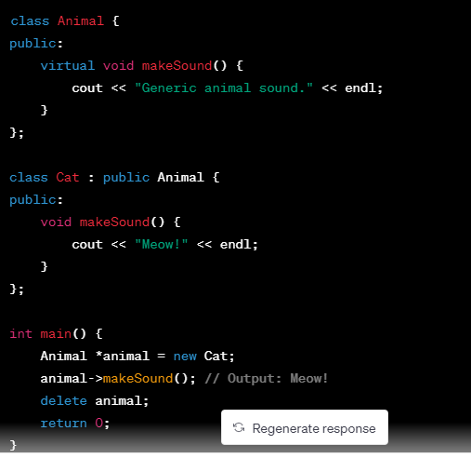

In this example, the **Animal** class has a virtual method called **makeSound()**, which is overridden in the **Cat** subclass. When the **makeSound()** method is called on an object of the **Cat** class, the **Cat** class's implementation of the method is executed, which outputs "Meow!" to the console.

Function overriding allows a subclass to provide its own implementation of a method that is already defined in its superclass, thereby allowing for more specialized behavior.

Polymorphism, on the other hand, is a broader concept that refers to the ability of objects of different classes to be treated as if they were of the same class. Function overriding is just one way to achieve polymorphism. Another way to achieve polymorphism is through function overloading, which allows multiple functions with the same name but different parameters to be defined in the same scope.

In conclusion, function overriding is a technique used to provide a specialized implementation of a method in a subclass, while polymorphism is a broader concept that allows objects of different classes to be treated as if they were of the same class, thereby increasing flexibility and reusability of code.

**OOP Pillars**

Object-oriented programming (OOP) is a programming paradigm that is based on the concept of objects. OOP has four pillars: encapsulation, inheritance, polymorphism, and abstraction. These pillars provide the foundation for writing clean, efficient, and maintainable code.

1. Encapsulation:

Encapsulation is the practice of hiding the implementation details of an object from the outside world, and providing a well-defined interface for interacting with the object. Encapsulation helps to protect the object's data from accidental modification, and provides a way to change the implementation of an object without affecting the code that uses it.

Example: A bank account is an example of encapsulation. The account holder can access their account balance, make deposits and withdrawals, and view their transaction history, but they cannot see how the bank stores their account information or performs the calculations necessary to update their balance.

Advantages:

* Encapsulation provides a way to protect an object's data from accidental modification, which can help prevent bugs and security vulnerabilities.
* Encapsulation makes it easier to change the implementation of an object without affecting the code that uses it, which can make it easier to maintain and extend software.

Disadvantages:

* Encapsulation can make it harder to debug code, since the implementation details of an object are hidden from the outside world.
* Encapsulation can make it harder to test code, since it may be difficult to access an object's internal state.

Real-life examples:

* A car engine is encapsulated, so that the driver can operate the car without knowing how the engine works.
* A mobile phone is encapsulated, so that the user can make calls, send texts, and use apps without knowing how the phone's hardware and software work together.

1. Inheritance:

Inheritance is the practice of creating a new class that inherits properties and behavior from an existing class. The new class, called the subclass or derived class, can add or override properties and behavior from the existing class, called the superclass or base class.

Example: A **Car** class might be the superclass, and a **SportsCar** class might be the subclass. The **SportsCar** class would inherit properties and behavior from the **Car** class, such as the ability to accelerate and brake, but would add or override properties and behavior specific to sports cars, such as the ability to go from 0 to 60 in a certain amount of time.

Advantages:

* Inheritance can make it easier to reuse code, since subclasses can inherit properties and behavior from a superclass.
* Inheritance can make it easier to extend and modify code, since subclasses can add or override properties and behavior from a superclass.

Disadvantages:

* Inheritance can make code more complex and harder to understand, since it can introduce dependencies between classes.
* Inheritance can make it harder to change the implementation of a class, since changes to a superclass can affect all of its subclasses.

Real-life examples:

* An animal hierarchy, with a **Mammal** class as the superclass and **Dog**, **Cat**, and **Horse** classes as subclasses.
* A software application, with a **Window** class as the superclass and **Dialog**, **Button**, and **Menu** classes as subclasses.

1. Polymorphism:

Polymorphism is the practice of using a single interface to represent multiple types. Polymorphism can be achieved through function overloading or function overriding.

Example: A **Shape** class might have a method called **draw()**, which is implemented differently by subclasses such as **Circle**, **Square**, and **Triangle**.

Advantages:

* Polymorphism can make code more flexible and adaptable, since it can work with different types of objects without needing to know their specific type.
* Polymorphism can make code more readable and maintainable

**Abstraction vs Encapsulation**

Encapsulation is the process of hiding implementation details and providing a public interface for interacting with an object. It helps to achieve data hiding and provides a way to restrict access to methods and variables in a class.

Abstraction is the process of simplifying complex systems by breaking them down into smaller, more manageable parts. It helps to create a more generalized view of an object, where only the essential details are shown to the user, and the rest of the information is hidden

**The main difference between encapsulation and abstraction is that encapsulation focuses on hiding the internal details of an object, while abstraction focuses on hiding unnecessary details and showing only the essential information.**

Real-life examples of encapsulation and abstraction:

1. Encapsulation: A bank account is a good example of encapsulation. The internal workings of the bank account, such as the data structure used to store the account details, are hidden from the user. Instead, the user interacts with the account through a public interface that allows them to perform operations like depositing, withdrawing, or checking the account balance.
2. Abstraction: A car is a good example of abstraction. A driver only needs to know how to operate the car using its controls, such as the steering wheel, pedals, and dashboard. The driver does not need to know how the engine, transmission, or other complex components work.

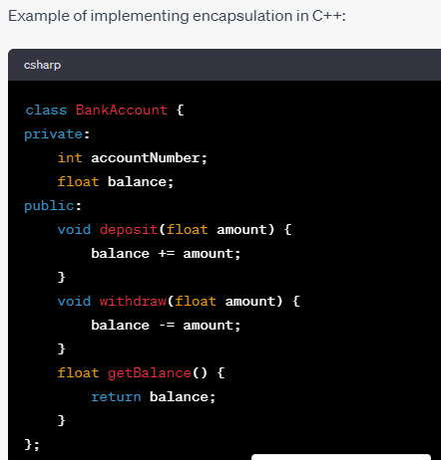

In this example, the **accountNumber** and **balance** variables are private, which means they cannot be accessed from outside the class. The **deposit**, **withdraw**, and **getBalance** methods provide a public interface for interacting with the **BankAccount** object

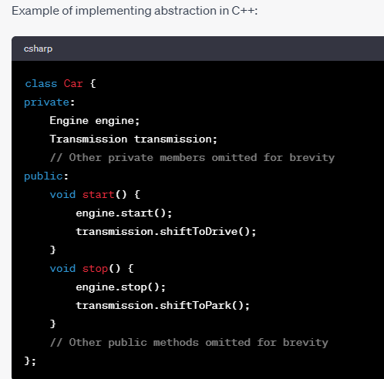

In this example, the **Car** class is composed of other classes such as **Engine** and **Transmission**. The user only needs to know how to start and stop the car, and the **Car** class handles the complex details of starting and stopping the engine and shifting gears.

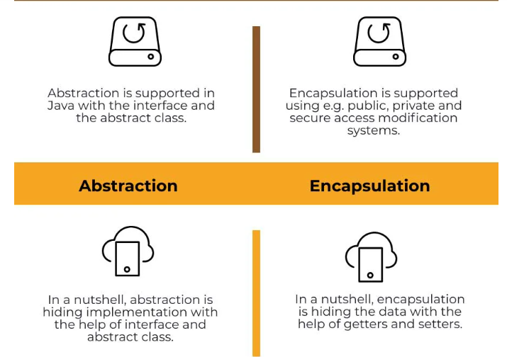

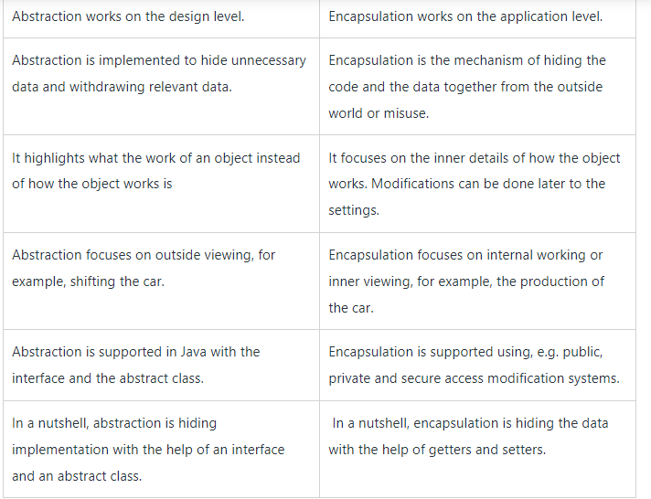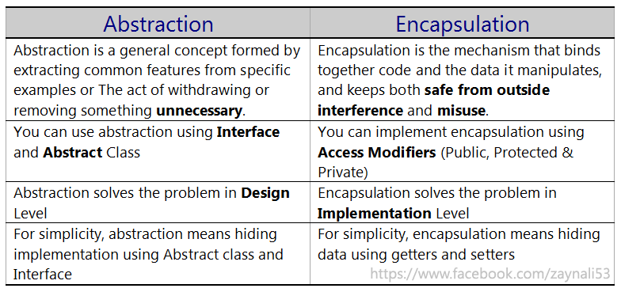v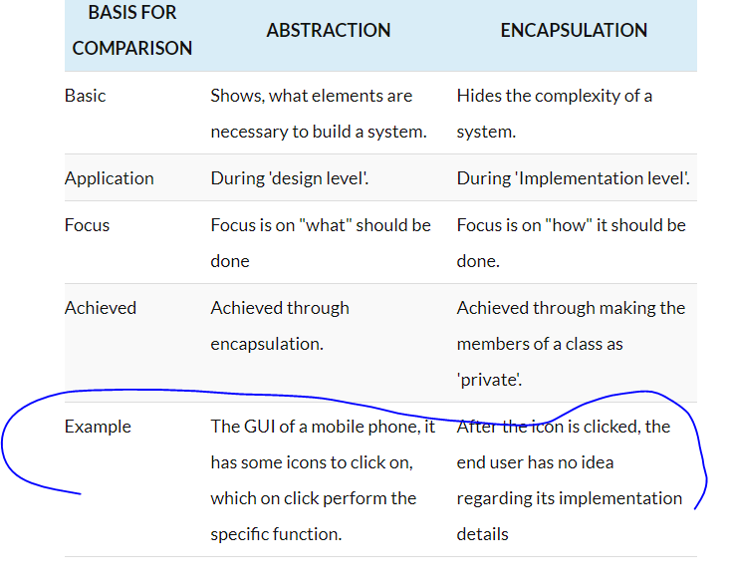

**Diamond Problem**

The diamond problem is a common issue that arises in multiple inheritance when a subclass inherits from two or more classes that have a common base class. In this situation, the subclass may end up with two instances of the common base class, leading to ambiguity and conflicts in the program.

Here is an example that illustrates the diamond problem:

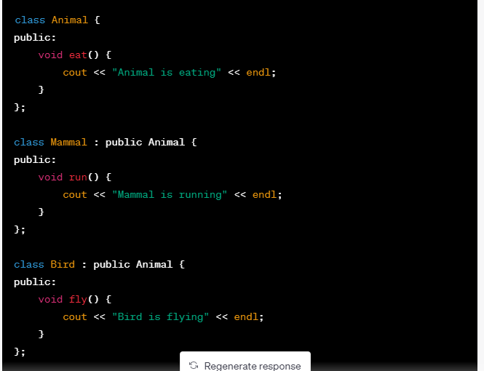

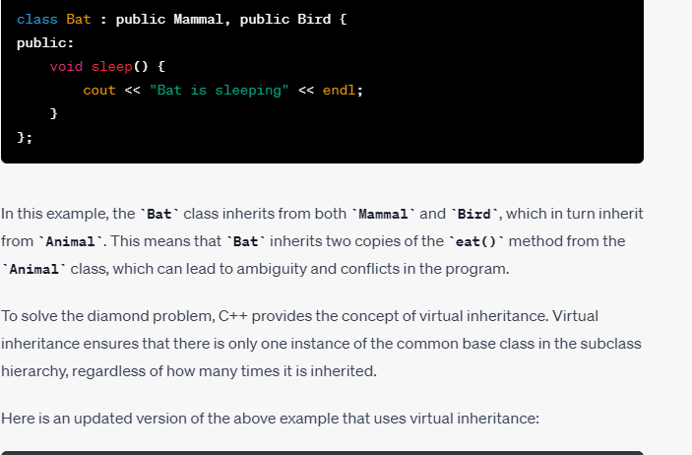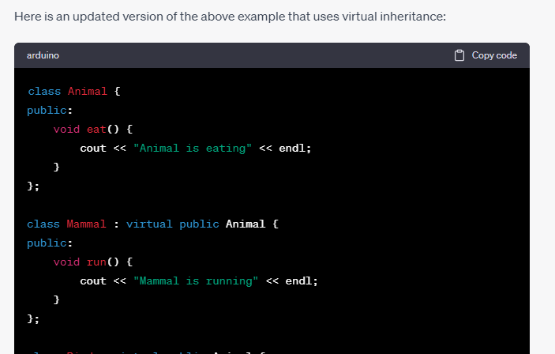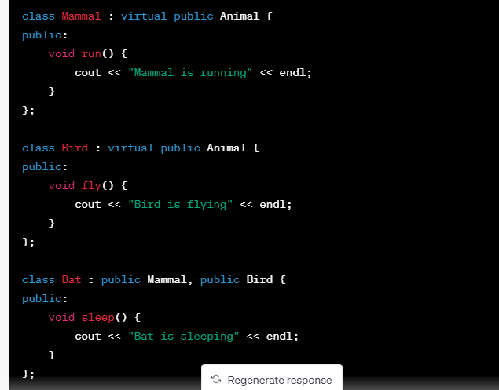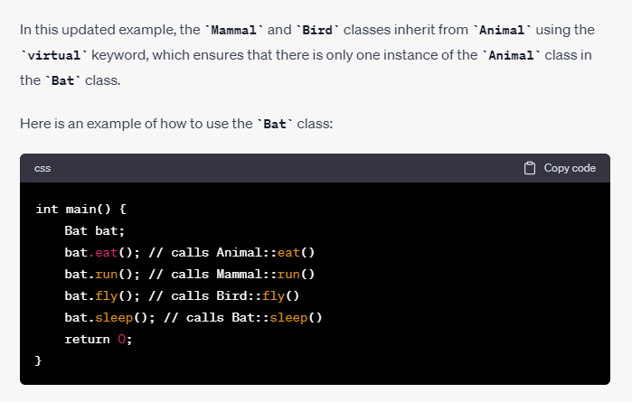In this example, the **Bat** object can call all of the methods inherited from **Mammal**, **Bird**, and **Animal** without any ambiguity or conflicts.

No, static variables cannot be declared as private members of a class in C++. The `static` keyword is used to declare class-level or global variables that are shared among all instances of the class, and they are typically accessed using the class name rather than an instance of the class.

In C++, the accessibility of class members (variables and functions) is controlled by access specifiers such as `public`, `private`, and `protected`. However, these access specifiers do not apply to static variables, as they belong to the class itself rather than a specific instance.

Static variables are typically declared in the class definition but outside of any member functions, and they are accessed using the scope resolution operator `::`. Here's an example:

```cpp

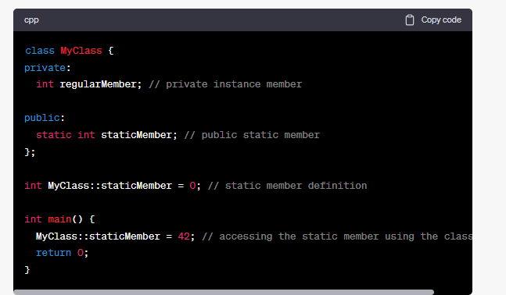

In the example above, `staticMember` is a static variable of the `MyClass` class, which can be accessed using `MyClass::staticMember` outside of any member functions.

If you want to control the access to a static variable, you can define public or private member functions that provide access to it. These member functions can then be used to manipulate the static variable while enforcing the desired access restrictions.

**can we assign some value to static member insde the class**

No, you cannot assign a value to a static member inside the class declaration in C++. You can only declare the static member inside the class, and then you need to provide the definition and initialization of the static member outside the class, typically in the source file (.cpp).

Here's an example to illustrate this:

```cpp

#include <iostream>

class MyClass {

public:

static int count; // Declaration of static variable

};

int MyClass::count = 0; // Definition and initialization of static variable

int main() {

std::cout << "Count: " << MyClass::count << std::endl; // Output: Count: 0

return 0;

}

```

In the above code, the static variable `count` is declared inside the `MyClass` class. Then, outside the class definition, the static variable is defined and initialized to 0 using the scope resolution operator `::` and the assignment operator `=`.

Once the static member is defined and initialized, you can access it using the class name, as shown in the `main()` function.

It's important to note that the initialization of a static member inside the class itself is not allowed in C++. The initialization needs to be done outside the class, usually in a source file, to ensure that it is only performed once and not duplicated across multiple translation units. The initialization of a static member inside the class itself is not allowed in C++ due to the language's design and the requirements for memory management and object initialization.

When a class is defined, the compiler determines the memory layout and size of each object of that class. If the initialization of a static member were allowed inside the class, it would mean that each object of the class would have its own copy of the static member, which goes against the concept of a static member being shared among all objects of the class.

To ensure that a static member is shared among all objects and has a single instance, the initialization of a static member needs to be performed outside the class, typically in a source file (.cpp). This ensures that the initialization happens only once, regardless of the number of objects created.

Furthermore, allowing the initialization of a static member inside the class itself could lead to problems related to multiple definition errors. If a header file containing the class definition is included in multiple source files, each source file would attempt to initialize the static member, resulting in multiple definitions of the same symbol.

By requiring the initialization of a static member to be done outside the class, C++ enforces a clear separation between declaration and definition, avoiding duplication and ensuring consistent behavior across multiple translation units.

**Static Variable**

A static variable in C++ is a variable that is shared among all instances of a class or within a function. It retains its value between multiple function calls or across different object instances. Static variables are declared with the `static` keyword and have a lifetime that extends throughout the program's execution.

Static variables are commonly used to store data that needs to be shared across instances of a class or retain its value between function calls. Here's an example that demonstrates the usage of static variables:

```cpp

#include <iostream>

class MyClass {

public:

static int count; // Declaration of static variable

MyClass() {

count++; // Increment count on each object creation

}

static void displayCount() {

std::cout << "Count: " << count << std::endl;

}

};

int MyClass::count = 0; // Definition and initialization of static variable

int main() {

MyClass obj1;

MyClass::displayCount(); // Output: Count: 1

MyClass obj2;

MyClass::displayCount(); // Output: Count: 2

MyClass obj3;

MyClass::displayCount(); // Output: Count: 3

return 0;

}

In this example, the class `MyClass` has a static variable `count`. Each time an object of `MyClass` is created, the constructor is called and increments the value of `count`. The `displayCount()` function is defined as a static member function, allowing it to access the static variable `count` directly.

When we run the program, the static variable `count` keeps track of the number of `MyClass` objects that have been created. In the `main()` function, we create three objects of `MyClass`, and each time we call `displayCount()`, it displays the current value of `count`.

Static variables are useful for scenarios where you want to maintain shared data or keep track of certain information across different instances of a class or function calls. They allow you to share and preserve data across the lifetime of the program or within the scope of a function.